CHAPTER 5
Elasticity & Its Application

INTRO — What Is Elasticity?

📖 Easy Definition
Elasticity is a number that tells us HOW MUCH buyers or sellers react when something changes — like a price change or an income change.
Think of a rubber band. Stretch it a lot → elastic. Barely moves → inelastic.
In economics: if price changes, does quantity demanded change a LOT or a LITTLE? That answer is elasticity.

💡 Real-Life Analogy
PETROL: Price goes up 20%. You still need to drive. You buy almost the same amount → INELASTIC (not very responsive).
RESTAURANT MEALS: Price goes up 20%. You cook at home instead. Demand falls a lot → ELASTIC (very responsive).

⭐ Why This Chapter Matters
Chapter 4 told us the direction of change (demand down when price up). Chapter 5 tells us the SIZE of that change. Elasticity is the measuring tool.
By the end you will answer: Why can good farming news be bad for farmers? Why did OPEC fail? Does drug interdiction reduce crime?

5-1 Price Elasticity of Demand (PED)

📖 Easy Definition
Price Elasticity of Demand (PED) measures how much the QUANTITY DEMANDED of a good responds when its PRICE changes.
Price up 10%, quantity drops 20% → big response → ELASTIC demand.
Price up 10%, quantity drops 2% → small response → INELASTIC demand.

💡 Simple Example
You sell ice cream. You raise price from $2 to $4 (price doubles). If most customers walk away → ELASTIC. If most still buy → INELASTIC.

5-1a The 4 Determinants of PED

📖 Key Idea
These four factors explain WHY demand for some goods is elastic while demand for others is inelastic. All four must be memorized for the exam.

The 4 Determinants — Summary Table

# | Factor | MORE Elastic When... | MORE Inelastic When...
1 | Availability of Substitutes | Many close substitutes exist (butter → use margarine) | Few/no substitutes (eggs, insulin)
2 | Necessity vs. Luxury | Luxury goods (sailboats, diamonds) — can skip them | Necessities (medicine, bread) — must have them
3 | Market Definition | Narrowly defined (vanilla ice cream — many flavors replace it) | Broadly defined (food — nothing replaces all food)
4 | Time Horizon | Long run — time to change habits, buy different cars | Short run — habits don't change overnight

🧠 Memory Trick — S·N·M·T
S = Substitutes | N = Necessity/Luxury | M = Market Definition | T = Time Horizon
Say: "Sellers Need Market Time" — four words, four factors!

💡 Real-Life Examples
Substitutes: Pepsi and Coke are close substitutes. If Coke price rises, people switch to Pepsi → elastic demand for Coke.
Necessity: Rice in Bangladesh — eaten every meal, price barely stops people → inelastic. Diamonds → luxury → elastic.
Market definition: 'Food' (broad) = inelastic. 'McDonald's Big Mac' (narrow) = elastic (many fast-food alternatives).
Time: Gasoline — 10% price rise reduces consumption ~2.5% after 1 year, but ~6% after 5 years (people buy fuel-efficient cars).
⭐ Exam Key Points
Whether a good is a necessity or luxury depends on BUYER PREFERENCES, not the product itself.
An avid sailor may view sailboats as a necessity and doctor visits as a luxury.
Vanilla ice cream is elastic — other flavors are near-perfect substitutes.
The broad category 'food' is inelastic — nothing replaces all food overall.

5-1b Computing Price Elasticity of Demand
📐 Main Formula
PED = % Change in Quantity Demanded ÷ % Change in Price
PED Price Elasticity of Demand — the number we calculate
%ΔQd Percentage change in quantity demanded
%ΔP Percentage change in price

📗 Book Example
Ice cream price rises 10%. Quantity demanded falls 20%.
PED = 20% ÷ 10% = 2
Quantity responded TWICE as much as price → Elastic demand (PED > 1)
⚠️ About the Minus Sign
Price and quantity always move in opposite directions (law of demand), so PED is technically negative.
Economists DROP the minus sign and report PED as a positive number.
A HIGHER number = MORE elastic. Don't panic about the negative sign.

Step-by-Step: How to Calculate PED

1 | Find % change in Quantity Demanded  (New Qty − Old Qty) ÷ Old Qty × 100

2 | Find % change in Price  (New Price − Old Price) ÷ Old Price × 100

3 | Divide  PED = %ΔQd ÷ %ΔP (drop the minus sign from result)

4 | Interpret  PED > 1 → Elastic | PED < 1 → Inelastic | PED = 1 → Unit Elastic

💡 Worked Example
Coffee price rises from $2 to $3. Quantity demanded falls from 100 to 70 cups.
Step 1 — %ΔQd = (70−100) ÷ 100 × 100 = −30% → drop minus → 30%
Step 2 — %ΔP = (3−2) ÷ 2 × 100 = 50%
Step 3 — PED = 30% ÷ 50% = 0.6
Step 4 — PED = 0.6 → Less than 1 → INELASTIC demand

5-1c The Midpoint Method

📖 The Problem & Solution
THE PROBLEM: Going from Point A→B gives a different PED than B→A. This is inconsistent.
A→B: Price +50%, Qty −33% → PED = 0.66
B→A: Price −33%, Qty +50% → PED = 1.5
Same two points — two different answers! This is the problem.

THE SOLUTION — Midpoint Method: Use the AVERAGE (midpoint) of the two values as the base for % calculations. Always gives the same answer in both directions.

📐 Midpoint Method Formula
PED = [(Q₂−Q₁) / ((Q₂+Q₁)/2)] ÷ [(P₂−P₁) / ((P₂+P₁)/2)]
Q₁, P₁ Original quantity and price (starting point)
Q₂, P₂ New quantity and price (ending point)
(Q₁+Q₂)/2 Midpoint = average of the two quantities (use as base)
(P₁+P₂)/2 Midpoint = average of the two prices (use as base)

Step-by-Step: Midpoint Calculation (Book Example — Points A & B)

1 | Identify both points  A: P=$4, Q=120 | B: P=$6, Q=80

2 | Midpoint price  (4+6) ÷ 2 = $5

3 | Midpoint quantity  (120+80) ÷ 2 = 100

4 | %ΔP  (6−4) ÷ 5 × 100 = 40%

5 | %ΔQd  (80−120) ÷ 100 × 100 = −40% → drop minus → 40%

6 | PED = 40% ÷ 40% = 1.0 (Unit Elastic)  Going B→A also gives 40% ÷ 40% = 1.0 ✓ Same answer both directions!

⭐ Book MCQ Practice — Midpoint Method
Q: Price rises from $8 to $12. Qty demanded falls from 110 to 90. What is PED?
Midpoint P = (8+12)/2 = 10 | %ΔP = (12−8)/10 × 100 = 40%
Midpoint Q = (110+90)/2 = 100 | %ΔQ = (90−110)/100 × 100 = 20%
PED = 20% ÷ 40% = 0.5 = 1/2 → INELASTIC (Book answer: choice b)
⚠️ Most Common Mistake
Students use the OLD value as the base instead of the midpoint (average) → gets wrong answer.
Always divide by the AVERAGE of the two values when using the midpoint method.

5-1d The 5 Types of Demand Curves

📖 Key Rule
FLATTER demand curve → MORE elastic. | STEEPER demand curve → MORE inelastic.
There are 5 types, ranging from perfectly inelastic (vertical line) to perfectly elastic (horizontal line).

Type | Elasticity | Curve Shape | What It Means | Example
Perfectly Inelastic | E = 0 | Vertical line ↕ | Any price change → quantity unchanged | Life-saving insulin
Inelastic | E < 1 | Steep downward | Price up a lot → qty falls a little | Cigarettes, petrol, rice
Unit Elastic | E = 1 | Moderate slope | Price & qty change by same % | Some manufactured goods
Elastic | E > 1 | Gentle/flat slope | Small price rise → big qty drop | Restaurant meals, luxury cars
Perfectly Elastic | E = ∞ | Horizontal line ↔ | Any price rise → qty falls to zero | Perfectly competitive market

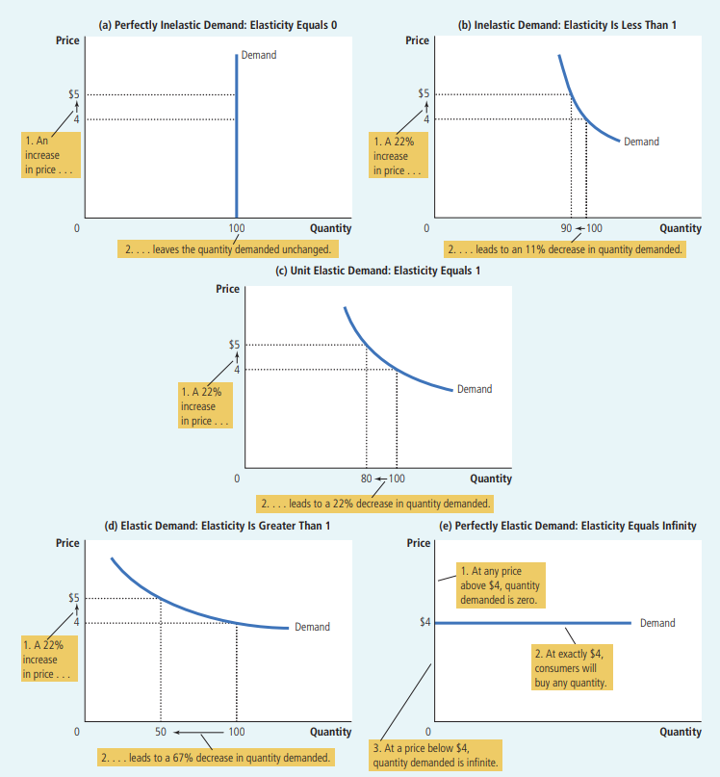

Real-World Price Elasticities (Book FYI Box)

Good | PED Value | Type
Eggs | 0.1 | Very Inelastic
Healthcare | 0.2 | Very Inelastic
Cigarettes | 0.4 | Inelastic
Rice | 0.5 | Inelastic
Housing | 0.7 | Inelastic
Beef | 1.6 | Elastic
Peanut Butter | 1.7 | Elastic
Restaurant Meals | 2.3 | Very Elastic
Mountain Dew (soda) | 4.4 | Highly Elastic
🧠 Memory Trick (From the Book Itself!)
"Inelastic curves look like the letter I" — this is literally stated in Mankiw's textbook.
A vertical demand curve = perfectly inelastic = shaped like the letter I.
Use this on your next exam whenever asked about curve shapes!

5-1e Total Revenue & Price Elasticity of Demand

📖 What Is Total Revenue?
Total Revenue (TR) = Price × Quantity (P × Q)
It is the total money that buyers pay and sellers receive.
On a demand graph, TR is the RECTANGLE area under the price line (height = P, width = Q).
Book example: P = $4, Q = 100 → TR = $4 × 100 = $400

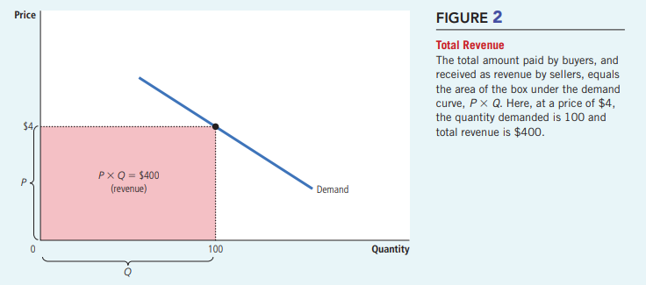

The Golden Rules — Total Revenue & Elasticity

Demand Type | PED | Price RISES → TR... | Price FALLS → TR...
Inelastic | < 1 | RISES ↑ (same direction) | FALLS ↓
Unit Elastic | = 1 | UNCHANGED → | UNCHANGED →
Elastic | > 1 | FALLS ↓ (opposite direction) | RISES ↑

💡 WHY Does This Happen? The Logic
INELASTIC (e.g., medicine): You raise price. People still buy nearly the same amount. The 'price gain' is bigger than the 'quantity loss.' → TR goes UP.
ELASTIC (e.g., restaurant): You raise price. Many customers leave. The 'quantity loss' is bigger than the 'price gain.' → TR goes DOWN.
Book numbers — Inelastic: P rises $4→$5, Q falls 100→90. TR: $400 → $450 ↑ (Area A > Area B)
Book numbers — Elastic: P rises $4→$5, Q falls 100→70. TR: $400 → $350 ↓ (Area A < Area B)

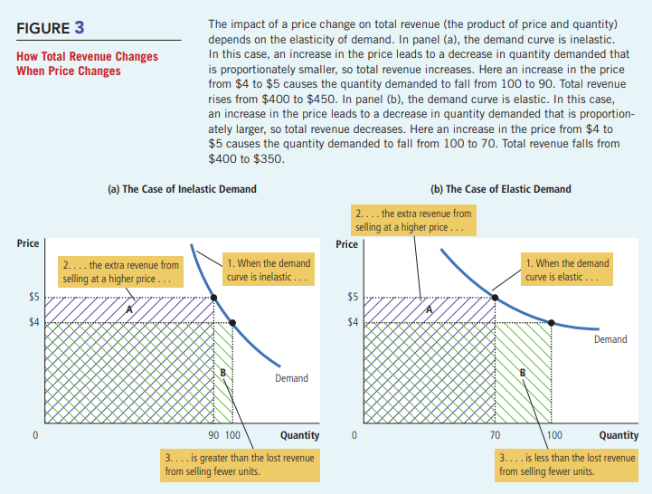

5-1f Elasticity Along a Linear Demand Curve

📖 The Big Surprise
A straight (linear) demand curve has a CONSTANT SLOPE — but its ELASTICITY CHANGES at every point!
Most students assume: 'straight line = constant elasticity.' This is WRONG.
WHY? Slope = ratio of absolute changes (ΔP/ΔQ). Elasticity = ratio of PERCENTAGE changes (%ΔQd / %ΔP). These are different things!

💡 Why Elasticity Changes Along a Straight Line
AT THE TOP (high P, low Q): A $1 price rise is a SMALL % of a high price. A 2-unit qty drop is a LARGE % of a small qty. So %ΔQd > %ΔP → ELASTIC.
AT THE BOTTOM (low P, high Q): A $1 price rise is a LARGE % of a low price. A 2-unit qty drop is a SMALL % of a large qty. So %ΔQd < %ΔP → INELASTIC.

⭐ The Three-Zone Rule for Linear Demand Curves
UPPER HALF of the curve → ELASTIC (E > 1)
EXACT MIDPOINT of the curve → UNIT ELASTIC (E = 1)
LOWER HALF of the curve → INELASTIC (E < 1)

TOTAL REVENUE IS MAXIMIZED at the midpoint (unit elastic). TR rises as price falls along the elastic upper half, then falls further along the inelastic lower half.

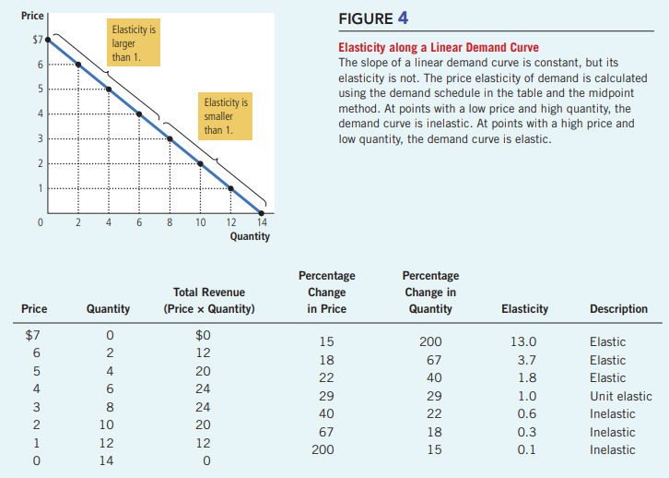

Data Table: Elasticity & TR Along a Linear Demand Curve

Price | Quantity | TR = P×Q | Elasticity | Zone
$7 | 0 | $0 | 13.0 | Elastic
$6 | 2 | $12 | 3.7 | Elastic
$5 | 4 | $20 | 1.8 | Elastic
$4 | 6 | $24 | 1.0 | Unit Elastic ← TR MAX
$3 | 8 | $24 | 0.6 | Inelastic
$2 | 10 | $20 | 0.3 | Inelastic
$1 | 12 | $12 | 0.1 | Inelastic

Note: Data from Figure 4 (Mankiw). TR is maximized at $24 where elasticity = 1.

5-1g Other Demand Elasticities

Income Elasticity of Demand (YED)

📐 Income Elasticity Formula
YED = % Change in Quantity Demanded ÷ % Change in Income
Positive (+) NORMAL good — buy MORE when income rises
Negative (−) INFERIOR good — buy LESS when income rises
Large positive LUXURY good (restaurants, holidays, diamonds)
Small positive NECESSITY (food, clothing, basic goods)

Cross-Price Elasticity of Demand (XED)

📐 Cross-Price Elasticity Formula
XED = %ΔQd of Good 1 ÷ %ΔP of Good 2
Positive (+) SUBSTITUTES — goods that compete (Pepsi & Coke, butter & margarine)
Negative (−) COMPLEMENTS — goods used together (computers & software, cars & petrol)
Zero (0) UNRELATED goods — no connection

📈 Income Elasticity (YED)  - Formula: %ΔQd ÷ %ΔIncome  - Positive → Normal good (buy more when richer)  - Negative → Inferior good (buy less when richer)  - Small positive → Necessity (food, clothing)  - Large positive → Luxury (caviar, diamonds) | 🔄 Cross-Price Elasticity (XED)  - Formula: %ΔQd Good1 ÷ %ΔP Good2  - Positive → Substitutes (Pepsi & Coke)  - Negative → Complements (cars & petrol)  - Zero → Unrelated goods  - Measures how two goods are RELATED

Elasticity | Sign | Meaning | Example
YED | Positive (+) | Normal good | Restaurants, cars, holidays
YED | Negative (−) | Inferior good | Bus rides, instant noodles
XED | Positive (+) | Substitutes | Pepsi & Coke
XED | Negative (−) | Complements | Computers & software

⚠️ Common Confusion — Inferior ≠ Bad Quality
An INFERIOR GOOD is NOT a low-quality product.
It means: when your income goes UP, you buy LESS of it (because you switch to better alternatives).
Example: Bus rides. When people get richer, they buy cars. Bus rides = inferior good — not because buses are bad, but because richer people switch away from them.
💡 Real-Life Examples
YED: Income doubles → you eat at restaurants 3× more (luxury, large YED) but buy only slightly more rice (necessity, small YED).
XED: Price of Coke rises → people buy more Pepsi (positive XED = substitutes). Price of printers rises → people buy less ink (negative XED = complements).

5-2 Price Elasticity of Supply (PES)

📖 Easy Definition
Price Elasticity of Supply (PES) measures how much the QUANTITY SUPPLIED changes when the PRICE changes.
When price rises, do sellers produce a LOT more or just a LITTLE more?

📐 Price Elasticity of Supply Formula
PES = % Change in Quantity Supplied ÷ % Change in Price
PES > 1 Elastic supply — sellers respond a lot
PES < 1 Inelastic supply — sellers barely change quantity
PES = 0 Perfectly inelastic — fixed supply (beachfront land)
PES = ∞ Perfectly elastic — quantity adjusts completely

5-2a Key Determinant: Production Flexibility

🏖️ Inelastic Supply (PES < 1)  - Cannot produce more easily  - Fixed inputs (beachfront land, rare art)  - Short run — factory capacity is fixed  - Supply curve is steep  - Example: Beachfront land, Picasso paintings | 🏭 Elastic Supply (PES > 1)  - Can expand production easily  - Manufactured goods (books, TVs, cars)  - Long run — build new factories, hire more  - Supply curve is flat/gentle  - Example: Books, electronics, clothing

Short Run vs Long Run for Supply

Time Period | PES | Why?
Short Run | Low — Inelastic | Factories have fixed capacity. Cannot quickly expand or shrink. Supply barely responds to price changes.
Long Run | High — Elastic | New factories built, new firms enter, old ones exit. Quantity supplied can change substantially over time.

5-2b Computing PES — Worked Example: Milk Farmers

💡 Step-by-Step Calculation
Milk price rises from $2.85 to $3.15. Production rises from 9,000 to 11,000 gallons.

Step 1 — Midpoint price: (2.85+3.15) ÷ 2 = $3.00
Step 2 — %ΔP: (3.15−2.85) ÷ 3.00 × 100 = 10%
Step 3 — Midpoint qty: (9,000+11,000) ÷ 2 = 10,000
Step 4 — %ΔQs: (11,000−9,000) ÷ 10,000 × 100 = 20%
Step 5 — PES = 20% ÷ 10% = 2 → Elastic supply (qty responds TWICE as much as price)

5-2c The 5 Types of Supply Curves

Type | PES | Curve Shape | Example
Perfectly Inelastic | E = 0 | Vertical ↕ | Beachfront land, original artworks
Inelastic | E < 1 | Steep upward slope | Farm crops in the short run
Unit Elastic | E = 1 | Moderate slope | Some manufactured goods
Elastic | E > 1 | Gentle/flat slope | Books, cars, electronics
Perfectly Elastic | E = ∞ | Horizontal ↔ | Firms in perfectly competitive market

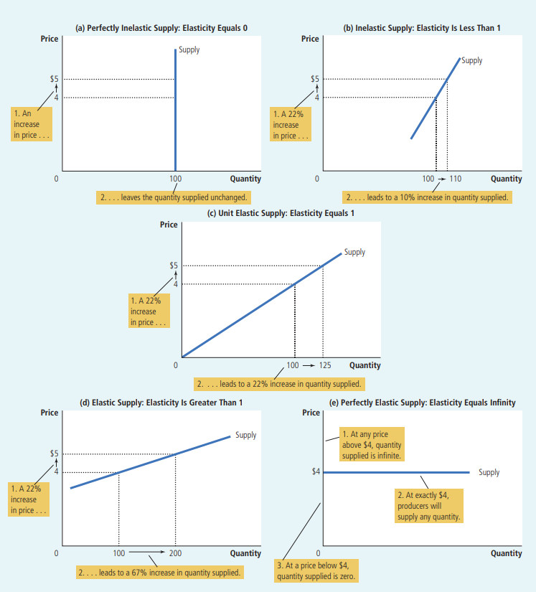

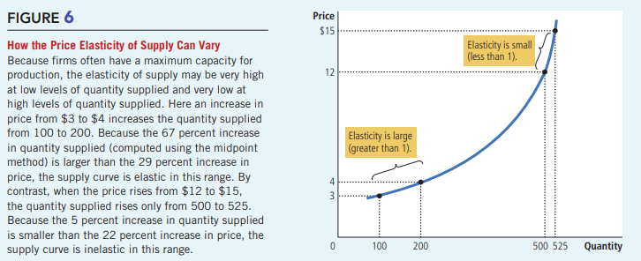

⚠️ PED vs PES — Don't Mix These Up
PED (Demand): affects BUYERS/CONSUMERS | Curve slopes DOWNWARD | Determined by substitutes, necessity, time
PES (Supply): affects SELLERS/PRODUCERS | Curve slopes UPWARD | Determined by production flexibility, time
BOTH are more elastic in the LONG RUN | BOTH always reported as positive numbers

5-3a Application 1: Can Good News for Farming Be Bad News for Farmers?

📖 The Surprising Question
Scientists invent a new wheat hybrid that increases yield by 20%. Is this good or bad news for farmers?
SURPRISING ANSWER: It can be BAD news for farmers' total revenue!

Step-by-Step Analysis

1 | New hybrid → Supply increases  Farmers produce 20% more wheat at any price → Supply curve shifts RIGHT (S₁ → S₂)

2 | Demand stays the same  Consumers' desire to buy wheat doesn't change because of a new farming method → Demand curve unchanged

3 | New equilibrium: Qty ↑, Price ↓  Book example: Qty sold rises 100→110. Price falls $3→$2

4 | Demand for wheat is INELASTIC  Wheat/food has few substitutes and is a necessity → PED < 1

5 | Total Revenue FALLS!  Old TR = $3 × 100 = $300. New TR = $2 × 110 = $220. Revenue fell by $80!

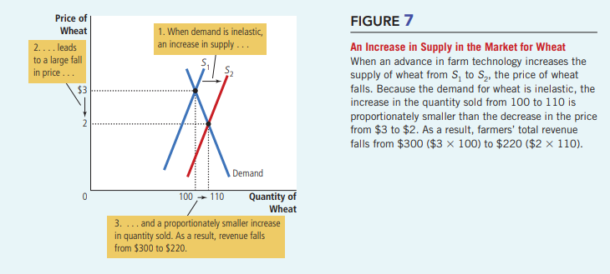

💡 Why Don't Farmers Refuse to Use the New Technology?
Each individual farmer is a tiny part of the whole wheat market. For any given market price, it is always rational for ONE farmer to grow more using the new hybrid — she earns more.
But when ALL farmers do this together, total supply surges, price crashes, and everyone earns less.
This is a classic collective action problem — individually rational behavior leads to a collectively bad outcome.
⭐ Key Exam Points
US farm employment dropped from 17% of the workforce in 1950 to just 2% today — technology boosted supply, inelastic food demand drove revenues down, millions left farming.
Government farm programs sometimes pay farmers NOT to plant crops — restricting supply keeps prices high. With inelastic demand: lower supply = higher total revenue for farmers.
What helps farmers (restricted supply, higher prices) HURTS consumers (higher food prices). Always a trade-off.
⚠️ Exam Trap
Students assume 'more production = more revenue.' With INELASTIC demand, the opposite is true.
Always ask: What is the elasticity of demand? That determines whether a supply increase helps or hurts total revenue.

5-3b Application 2: Why Did OPEC Fail to Keep Oil Prices High?

📖 Background
OPEC (Organization of Petroleum Exporting Countries) agreed to reduce oil supply to raise prices and increase revenues. It worked short-run — but failed long-run. Why? Elasticity changes over time!
Key timeline: 1973-74: oil price up 50%+. 1979-81: price doubled again. 1982-85: price fell 10%/year. 1986: cartel collapsed, price plunged 45%. By 1990: back to 1970 level.

⚡ Short Run — OPEC Succeeds  - Supply inelastic (can't quickly find new oil)  - Demand inelastic (can't quickly change cars/habits)  - Both curves are STEEP  - OPEC cuts supply → supply shifts LEFT  - Steep curves → LARGE price increase  - OPEC earns much more even selling less oil | ⏳ Long Run — OPEC Fails  - Supply elastic (fracking, new oil fields explored)  - Demand elastic (fuel-efficient cars, conservation)  - Both curves become FLAT  - Same supply cut → SMALLER price rise  - Revenue doesn't increase much  - OPEC members defect → cartel breaks down

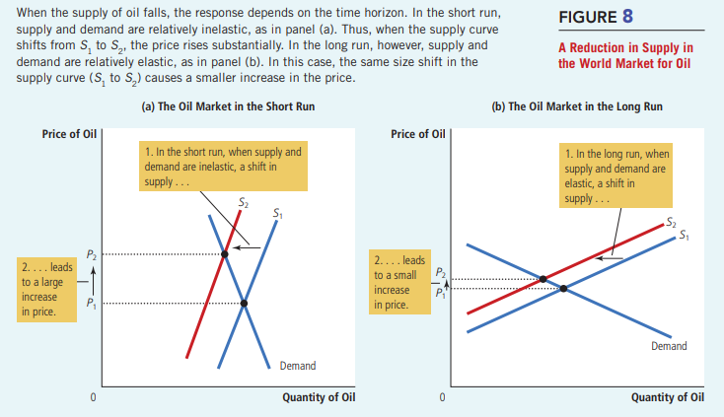
⭐ Key Lesson (Direct Quote from Book)
"Raising prices is easier in the short run than in the long run."
In markets where short-run elasticity is low but long-run elasticity is high, any price-raising strategy gradually loses power as producers and consumers adapt.
This applies to any cartel, monopoly, or government price-fixing scheme.

5-3c Application 3: Does Drug Interdiction Increase or Decrease Crime?

📖 The Policy Question
The government spends billions on drug interdiction (stopping drugs from entering the country, arresting suppliers). Does this reduce crime — or actually INCREASE it?
The answer depends entirely on the ELASTICITY OF DEMAND for drugs.

🚔 Policy A: Drug Interdiction (Attack Supply)  - Arrests suppliers → Supply shifts LEFT (S₁→S₂)  - Price of drugs RISES  - Quantity of drugs FALLS slightly  - Drug demand is INELASTIC (addicts can't easily stop)  - Total drug spending RISES (inelastic = P×Q up)  - Addicts need MORE money → steal MORE  - → CRIME INCREASES! | 📚 Policy B: Drug Education (Attack Demand)  - Reduces desire → Demand shifts LEFT (D₁→D₂)  - Both price AND quantity FALL  - Total drug spending FALLS  - Addicts need LESS money  - → Less theft, less robbery  - → CRIME DECREASES! ✓  - Also reduces drug use simultaneously

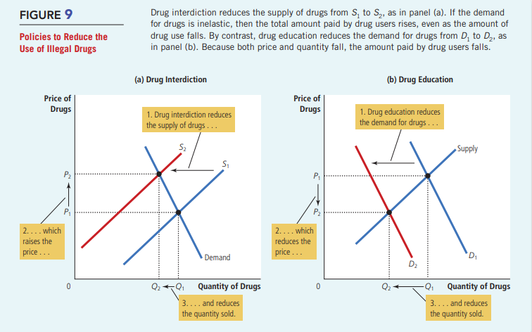

Factor | Interdiction (Supply ↓) | Education (Demand ↓)
Which curve shifts? | Supply — leftward | Demand — leftward
Effect on Price | RISES | FALLS
Effect on Quantity | FALLS slightly | FALLS
Total Drug Spending | RISES (inelastic demand) | FALLS
Effect on Crime | May INCREASE | DECREASES

💡 Short Run vs Long Run Caveat
SHORT RUN: Drug demand is inelastic (existing addicts won't stop due to higher prices). Interdiction → higher crime. Education → lower crime.
LONG RUN: Higher prices may deter young people from experimenting. Over time demand becomes more elastic → fewer new addicts → interdiction may eventually reduce crime.
Both sides of the policy debate have valid economic arguments. The book presents both views honestly.

Full Chapter Summary
Elasticity — Big Idea  Measures responsiveness. Tells us HOW MUCH quantity changes when price, income, or another good's price changes. Goes beyond just 'up or down.' | PED Formula  PED = %ΔQd ÷ %ΔP. Use midpoint method for consistency. Elastic >1 | Inelastic <1 | Unit =1. Always positive by convention.

4 Determinants of PED  Substitutes (more = elastic) · Necessity/Luxury (luxury = elastic) · Market definition (narrow = elastic) · Time (long run = elastic). Memory: SNMT. | Midpoint Method  Use average of two values as base. Avoids direction problem. Gives same answer whether going A→B or B→A.

5 Types of Demand Curves  Perfectly inelastic (vertical, E=0) → Inelastic → Unit elastic → Elastic → Perfectly elastic (horizontal, E=∞). Flatter = more elastic. | Total Revenue Rule  Inelastic: P & TR same direction. Elastic: P & TR opposite. Unit elastic: TR unchanged. TR maximized at unit elastic midpoint of linear curve.

Income Elasticity (YED)  Positive = normal good. Negative = inferior good. Large positive = luxury. Small positive = necessity. Formula: %ΔQd ÷ %ΔIncome. | Cross-Price Elasticity (XED)  Positive = substitutes (Pepsi & Coke). Negative = complements (computers & software). Formula: %ΔQd₁ ÷ %ΔP₂.

Price Elasticity of Supply  PES = %ΔQs ÷ %ΔP. Depends on production flexibility. Always more elastic in the long run. Vertical = perfectly inelastic (E=0). | Application 1: Farming  Better tech → supply↑ → price↓. With inelastic food demand → TR falls! Good tech news = bad revenue news for farmers as a group.

Application 2: OPEC Oil  Supply restriction works short run (inelastic). Fails long run as market becomes elastic. Key: raising prices easier short-run than long-run. | Application 3: Drug Policy  Interdiction (supply↓) → higher price → more crime (inelastic demand). Education (demand↓) → lower price AND qty → less crime. Education wins!

Ultra-Short Revision Sheet

Read this 5 minutes before your exam. Only the most critical facts.

⚡ CRITICAL FACTS — READ BEFORE EXAM
📌 Elasticity = measure of how much quantity responds to changes in price/income/other prices
📌 PED = %ΔQd ÷ %ΔP | Elastic > 1 | Inelastic < 1 | Unit = 1 | Always positive
📌 4 Determinants of PED: Substitutes · Necessity/Luxury · Market Definition · Time Horizon
📌 Midpoint method = use average of two values as base → same answer both directions
📌 TR rule — Inelastic: Price & TR move SAME way | Elastic: Price & TR move OPPOSITE ways
📌 Linear demand: Upper half = elastic | Midpoint = unit elastic | Lower half = inelastic
📌 TR is MAXIMIZED at the unit elastic midpoint of a linear demand curve
📌 YED positive = normal good | YED negative = inferior good (not bad quality!)
📌 XED positive = substitutes | XED negative = complements
📌 PES = %ΔQs ÷ %ΔP | More elastic in long run | Flexible production = elastic supply
📌 Farming: Better tech → supply↑ → price↓ → inelastic demand → TR↓ (bad for farmers!)
📌 OPEC: Short run inelastic → big price rise. Long run elastic → small price rise. Cartel power fades.
📌 Drug interdiction: Supply↓ → price↑ → inelastic drug demand → total spending↑ → MORE crime!
📌 Drug education: Demand↓ → both price and qty↓ → total spending↓ → LESS crime ✓
📌 Memory trick (from the book!): 'Inelastic curves look like the letter I' (vertical = I shape)

All Formulas at a Glance

Formula | What It Calculates
PED = %ΔQd / %ΔP | Demand responsiveness to own price
PES = %ΔQs / %ΔP | Supply responsiveness to own price
YED = %ΔQd / %ΔIncome | Demand responsiveness to income
XED = %ΔQd₁ / %ΔP₂ | How Good 1 reacts to Good 2's price
TR = P × Q | Total Revenue (the rectangle on the graph)
Midpoint P = (P₁+P₂)/2 | Base for midpoint % change calculation

Most Important Exam Questions & Model Answers

Short Questions (2–5 marks)

Short Question
Q1: Define price elasticity of demand. What does it measure?
- PED measures how much the quantity demanded responds to a change in price.
- Formula: PED = %ΔQd ÷ %ΔP. Always report as a positive number.
- PED > 1 = elastic (responsive). PED < 1 = inelastic (not responsive). PED = 1 = unit elastic.

Short Question
Q2: List and explain the four determinants of PED.
- (1) Availability of substitutes: more substitutes → more elastic (easy to switch).
- (2) Necessity vs. luxury: necessities (medicine) = inelastic; luxuries (diamonds) = elastic.
- (3) Market definition: narrowly defined markets are more elastic; broadly defined are more inelastic.
- (4) Time horizon: demand is more elastic in the long run (more time to adjust behavior).

Short Question
Q3: What is the midpoint method and why is it preferred?
- The midpoint method calculates % changes using the average of initial and final values as the base.
- It is preferred because the standard method gives different answers going A→B vs B→A.
- Midpoint method gives the same answer in both directions — more consistent and accurate.

Broad / Essay Questions (8–15 marks)

Broad Question
Q4: Explain the relationship between PED and total revenue. Use examples and diagrams.
- Total revenue TR = P × Q. On a demand diagram, TR = the shaded P×Q rectangle.
- INELASTIC demand (PED < 1): Price rises → qty falls proportionately less → TR rises. Same direction. Example: P $4→$5, Q 100→90, TR $400→$450 ↑
- ELASTIC demand (PED > 1): Price rises → qty falls proportionately more → TR falls. Opposite direction. Example: P $4→$5, Q 100→70, TR $400→$350 ↓
- UNIT ELASTIC (PED = 1): TR unchanged when price changes.
- Draw Figure 3: show Area A (gained) vs Area B (lost). Inelastic: A > B. Elastic: A < B.
- Along a linear demand curve: TR maximized at the unit elastic midpoint.

Broad Question
Q5: 'Good news for farming can be bad news for farmers.' Explain with elasticity.
- New farming technology → supply curve shifts right (S₁→S₂). Demand unchanged.
- New equilibrium: price falls ($3→$2), quantity rises (100→110).
- Demand for food/wheat is INELASTIC (necessity, few substitutes).
- With inelastic demand: % fall in price > % rise in quantity.
- Therefore TR falls: Old TR = $300 → New TR = $220. Farmers earn LESS.
- Historical evidence: U.S. farm employment fell from 17% (1950) to 2% today.
- Policy: Governments pay farmers NOT to plant crops → restricts supply → raises TR (inelastic demand).

Graph Questions

Graph Question
Q6: Draw and label the five types of demand curves. Explain each briefly.
- (a) Perfectly Inelastic (E=0): Draw a VERTICAL line. Label 'Demand.' At any price, qty stays at 100.
- (b) Inelastic (E<1): Steep downward line. Show price rise $4→$5 causes small qty fall (100→90).
- (c) Unit Elastic (E=1): Moderate slope. 22% price rise causes 22% qty fall.
- (d) Elastic (E>1): Gentle/flat slope. 22% price rise causes 67% qty fall.
- (e) Perfectly Elastic (E=∞): HORIZONTAL line at P=$4. Above $4 → qty = 0.
- Memory trick: Inelastic curve looks like the letter I (vertical). ✓

Analytical Questions

Analytical Question
Q7: Explain why drug interdiction may increase crime. Compare with drug education.
- Drug interdiction: arrests suppliers → supply shifts left → price rises, qty falls slightly.
- Drug demand is inelastic (addicts cannot easily stop using when price rises).
- With inelastic demand: % price rise > % qty fall → total spending by users RISES.
- Addicts need more money → steal more → CRIME INCREASES.
- Drug education: reduces demand → demand shifts left → both price AND qty fall.
- Total drug spending FALLS → less need to steal → CRIME DECREASES. Better short-run policy!
- Long-run caveat: higher prices from interdiction may deter new users → less crime eventually.
- Draw Figure 9: panel (a) interdiction (supply shift, inelastic demand), panel (b) education (demand shift).

Analytical Question
Q8: Why did OPEC succeed short-run but fail long-run? Explain with diagrams.
- OPEC cut production → supply shifted left in both short and long run (S₁→S₂).
- SHORT RUN: Both supply and demand are inelastic (steep curves). Same supply cut → LARGE price rise → OPEC revenues soar.
- LONG RUN: Both become more elastic (flat curves). Consumers buy fuel-efficient cars; new oil fields explored. Same supply cut → SMALL price rise → revenues barely improve.
- Draw Figure 8: two panels showing steep vs flat curves, same supply shift causing different price effects.
- Key lesson: 'Raising prices is easier in the short run than in the long run.' (direct book quote)

Common MCQ Concepts & Traps

These are the most-tested MCQ facts and the traps that catch students. Memorize all of them.

MCQ Fact 1: A life-saving medicine with NO close substitutes → SMALL (inelastic) PED.
⚠️ Trap: 'No substitute' sounds extreme → students think elastic. WRONG! No substitute = can't switch = inelastic. (Book Q1, Answer: a)

MCQ Fact 2: Midpoint Method: Price $8→$12, Qty 110→90. Midpoint P=10, Q=100. %ΔP=40%, %ΔQ=20%. PED = 0.5 = 1/2.
⚠️ Trap: Using old value ($8) as base instead of midpoint → wrong answer. (Book Q2, Answer: b)

MCQ Fact 3: A linear downward-sloping demand curve → 'inelastic at some points and elastic at others.'
⚠️ Trap: Students pick 'unit elastic' or 'constant elasticity.' A straight line does NOT have constant elasticity. (Book Q3, Answer: d)

MCQ Fact 4: Firms entering and exiting a market over time → the SUPPLY curve becomes more elastic.
⚠️ Trap: Students pick 'demand curve more elastic.' Entry/exit affects SUPPLY, not demand. (Book Q4, Answer: c)

MCQ Fact 5: An increase in supply will DECREASE total revenue if demand is INELASTIC.
⚠️ Trap: 'More supply = more revenue.' FALSE with inelastic demand — this is the farming application! (Book Q5, Answer: a)

MCQ Fact 6: Technology raises incomes and lowers prices. Spending rises if YED > 0 AND PED > 1.
⚠️ Trap: Students pick 'one, one.' Income just needs positive YED. Price needs PED > 1 for lower price to RAISE spending. (Book Q6, Answer: b)

MCQ Fact 7: POSITIVE income elasticity = NORMAL good. NEGATIVE income elasticity = INFERIOR good.
⚠️ Trap: 'Inferior' sounds like bad quality. It means buy LESS when income rises — nothing about quality.

MCQ Fact 8: POSITIVE cross-price elasticity = SUBSTITUTES. NEGATIVE cross-price elasticity = COMPLEMENTS.
⚠️ Trap: Students swap these. Substitutes (+): price of A rises → buy more B. Complements (−): price of A rises → buy less B.

MCQ Fact 9: Price rises and total revenue ALSO rises → demand must be INELASTIC (PED < 1).
⚠️ Trap: TR moved in same direction as price → always means inelastic demand. Opposite direction → elastic.

MCQ Fact 10: Drug interdiction reduces drug use BUT may increase drug-related CRIME.
⚠️ Trap: Students assume 'less drug use = less crime.' Not true if inelastic demand causes total spending to rise.

MCQ Fact 11: OPEC succeeded short-run because oil supply and demand are INELASTIC short-run.
⚠️ Trap: Students say OPEC failed because demand was elastic. NO — demand was INELASTIC initially. Elasticity INCREASED over time.

MCQ Fact 12: Supply of beachfront land → Perfectly Inelastic (E=0). Cannot produce more at any price.
⚠️ Trap: Confusing perfectly inelastic supply with inelastic demand — they are different curves!

⚠️ THE 5 BIGGEST EXAM TRAPS — Never Fall For These
Trap 1: 'Price rises → total revenue always rises' — FALSE when demand is ELASTIC!
Trap 2: 'A straight demand line has constant elasticity' — FALSE! Slope is constant, elasticity changes along the curve.
Trap 3: 'Drug interdiction always reduces crime' — NOT necessarily! With inelastic demand, it may actually INCREASE crime.
Trap 4: 'Inferior good = bad quality product' — FALSE! Inferior means you buy LESS of it when your income RISES.
Trap 5: 'Supply elasticity is the same short-run and long-run' — FALSE! Supply is always more elastic in the long run.

